**CSA0704-Computer Networks for Data Communication**

**LAB MANUAL**

**LIST OF EXPERIMENTS**

|  |  |  |
| --- | --- | --- |
| **Sl. No** | **Experiment** |  |
| **1.** | Configuration of Network Devices using Packet Tracer tools (Hub, Switch, Ethernet, Broadcast). |  |
| **2.** | Design and Configuration of Star Topologies using Packet Tracer. |  |
| **3.** | Design and Configuration of BUS Topologies using Packet Tracer. |  |
| **4.** | Design and Configuration of RING Topologies using Packet Tracer. |  |
| **5.** | Design and Configuration of Mesh Topologies using Packet Tracer. |  |
| **6.** | Design and Configuration of Tree Topologies using Packet Tracer. |  |
| **7.** | Design and Configuration of Hybrid Topologies using Packet Tracer. |  |
| **8.** | Data Link Layer Traffic Simulation using Packet Tracer Analysis of ARP. |  |
| **9.** | Data Link Layer Traffic Simulation using Packet Tracer Analysis of LLDP. |  |
| **10.** | Data Link Layer Traffic Simulation using Packet Tracer Analysis of CSMA/CD & CSMA/CA. |  |
| **11.** | Designing two different network with Static Routing techniques using Packet Tracer. |  |
| **12.** | Designing two different networks with Dynamic Routing techniques (RIP & OSPF) using Packet Tracer |  |
| **13.** | Design the Functionalities and Exploration of TCP using Packet Tracer. |  |
| **14.** | Design the Functionalities and Exploration of UDP using Packet Tracer. |  |
| **15.** | Design the network model for Subnetting – Class C Addressing using Packet Tracer. |  |
| **16.** | Simulating X, Y, Z Company Network Design and simulate using Packet Tracer. |  |
| **17.** | Configuration of DHCP (dynamic host configuration protocol) in packet Tracer. |  |
| **18.** | Configuration of firewall in packet tracer. |  |
| **19.** | Make a Computer Lab to transfer a message from one node to another to design and simulate using Cisco Packet Tracer. |  |
| **20.** | Simulate a Multimedia Network in Cisco Packet Tracer. |  |
| **21.** | IoT based smart home applications. |  |
| **22.** | Implementation of IoT based smart gardening. |  |
| **23.** | Implementation of IoT devices in networking. |  |
| **24.** | IOT Based Smart building using WPA Security & Radius Server. |  |
| **25.** | Transport layer protocol header analysis using Wire shark- TCP |  |
| **26.** | Transport layer protocol header analysis using Wire shark- UDP. |  |
| **27.** | Network layer protocol header analysis using Wire shark – SMTP |  |
| **28.** | Network layer protocol header analysis using Wire shark –ICMP. |  |
| **29.** | Network layer protocol header analysis using Wire shark – ARP |  |
| **30.** | Network layer protocol header analysis using Wire shark – HTTP. |  |
| **31.** | Identify and monitor the IP, network address, Trace the router information, how to take remote system and check the node connection in network |  |
| **32.** | Demonstration of PING operation using ICMP in Wireshark |  |
| **33.** | Implementation of Bit stuffing mechanism using C. |  |
| **34.** | Implementation of server – client using TCP socket programming. |  |
| **35.** | Implementation of server – client using UDP socket programming. |  |

**Date:**

# EXPERIMENT-1

**CONFIGURATION OF NETWORK COMPONENTS**

**Aim:** To Study the following Network Devices in Detail

* PC
* Server
* Repeater
* Hub
* Switch
* Bridge
* Router
* Gate Way
* Transmission medium

**Apparatus (Software): CISCO Packet tracer**.

1. Node: In a communications ***network***, a ***network node*** is a connection point that can receive, create, store or send data along distributed ***network*** routes.

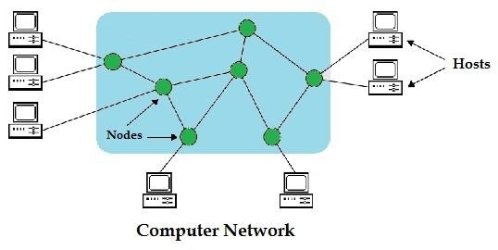

1. **Repeater:** Functioning at Physical Layer.

A **repeater** is an electronic device that receives a signal and retransmits it at a higher level and/or higher power, or onto the other side of an obstruction, so that the signal can cover longer distances.

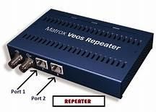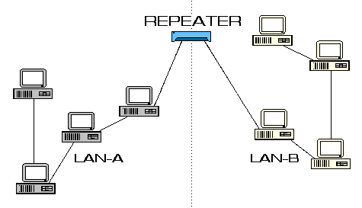

1. **Hub: Ethernet hub**, **active hub**, **network hub**, **repeater hub**

Hub or concentrator is a device for connecting multiple twisted pair or fiber optic Ethernet devices together and making them act as a single network segment. Hubs work at the physical layer (layer 1) of the OSI model. The device is a form of multiport repeater. Repeater hubs also participate in collision detection, forwarding a jam signal to all ports if it detects a collision.

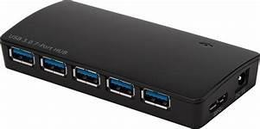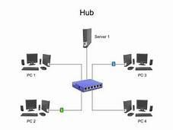

1. **Switch:** A **network switch** or **switching hub** is a computer networking device that connects network segments. The term commonly refers to a network bridge that processes and routes data at the data link layer (layer 2) of the OSI model. Switches that additionally process data at the network layer (layer 3 and above) are often referred to as Layer 3 switches or multilayer switches.

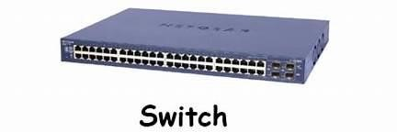

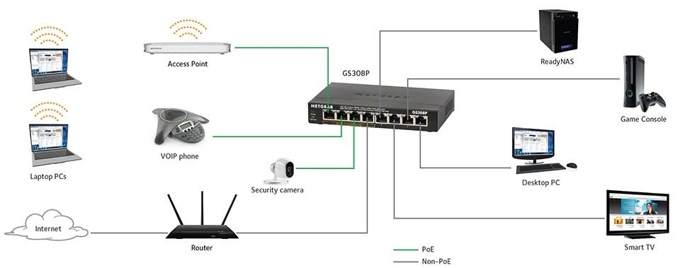

1. **Bridge:** A **network bridge** connects multiple network segments at the data link layer (Layer 2) of the OSI model. In Ethernet networks, the term bridge formally means a device that behaves according to the IEEE 802.1D standard. A bridge and switch are very much alike; a switch being a bridge with numerous ports. Switch or Layer 2 switch is often used interchangeably with bridge. Bridges can analyze incoming data packets to determine if the bridge is able to send the given packet to another segment of the network.

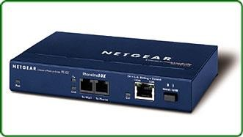

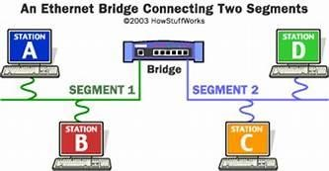

1. **Router:** A **router** is an electronic device that interconnects two or more computer networks, and selectively interchanges packets of data between them. Each data packet contains address information that a router can use to determine if the source and destination are on the same network, or if the data packet must be transferred from one network to another. The multiple routers are used in a large collection of interconnected networks, the routers exchange information about target system addresses, so that each router can build up a table showing the preferred paths between any two systems on the interconnected networks.

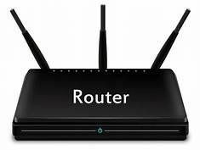

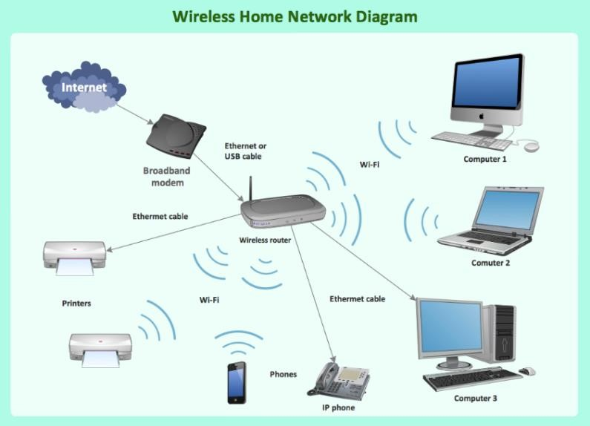

1. **Gate Way:** In a communication network, a network node equipped for interfacing with another network that uses different protocols. A gateway may contain devices such as protocol translators, impedance matching devices, rate converters, fault isolators, or signal translators as necessary to provide system interoperability. It also requires the establishment of mutually acceptable administrative procedures between both networks.

• A protocol translation/mapping gateway interconnects networks with different network protocol technologies by performing the required protocol conversions.

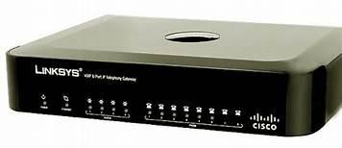

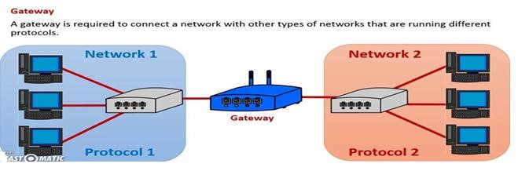

1. Server: A server is a type of [computer](https://www.webopedia.com/TERM/C/computer.html) or [device](https://www.webopedia.com/TERM/D/device.html) on a [network](https://www.webopedia.com/TERM/N/network.html) that manages network [resources.](https://www.webopedia.com/TERM/R/resource.html) Servers are often [dedicated,](https://www.webopedia.com/TERM/D/dedicated_server.html) meaning that they perform no other tasks besides their server tasks. On multiprocessing [operating systems,](https://www.webopedia.com/TERM/O/operating_system.html) however, a single computer can [execute](https://www.webopedia.com/TERM/E/execute.html) several [programs](https://www.webopedia.com/TERM/P/program.html) at once. A server in this case could refer to the program that is managing resources rather than the entire computer.

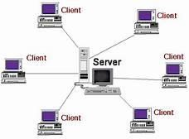

1. **Transmission media**: The medium through which the signals travel from one device to another. These are classified as guided and unguided. Guided media are those that provide a conduit from one device to another. Eg. Twisted pair, coaxial cable etc. Unguided media transport signals without using physical cables. Eg. Air.

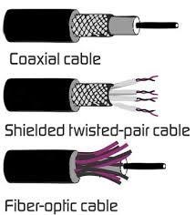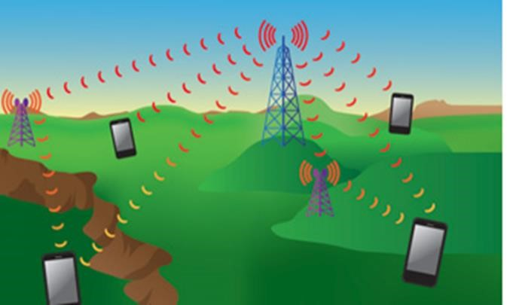

**Result:** Thus the network components are studied in detail.

**Date:**

# EXPERIMENT-2

**IMPLEMENTATION OF STAR TOPOLOGY USING PACKET TRACER**

**Aim:** To Implement a star topology using packet tracer and hence to transmit data between the devices connected using star topology.

**Software/Apparatus required:** Packet Tracer/End devices, bridge, connectors.

**Steps for building topology:**

**Step 1: Start Packet Tracer**

**Step 2: Choosing Devices and Connections**

**Step 3: Building the Topology – Adding Hosts**  Single click on the **End Devices**.

Single click on the **Generic** host.

Move the cursor into topology area.

Single click in the topology area and it copies the device.

**Step 4: Building the Topology – Connecting the Hosts to Switches**

Select a switch, by clicking once on **Switches** and once on a **2950-24** switch.

Add the switch by moving the plus sign “**+**”

**Step 5: Connect PCs to switch by first choosing Connections**

Click once on the **Copper Straight-through** cable

Click once on **PC2**

Choose **Fast Ethernet**

Drag the cursor to **Switch0**

Click once on **Switch0**

Notice the green link lights on **PC** Ethernet NIC and amber light **Switch port**. The switch port is temporarily not forwarding frames, while it goes through the stages for the Spanning Tree Protocol (STP) process. After about 30 seconds the amber light will change to green indicating that the port has entered the forwarding stage. Frames can now forwarded out the switch port.

**Step 6: Configuring IP Addresses and Subnet Masks on the Hosts**

To start communication between the hosts IP Addresses and Subnet Masks had to be

Configured on the devices. Click once on PC0. Choose the Config tab and click on FastEthernet0. Type the IP address in its field. Click on the subnet mask it will be generated automatically.

**Step 7: To confirm Data transfer between the devices**

Click on the node. Select desktop option and then command prompt. Once the window pops up, ping the IP address of the device to which node0 is connected. Ping statistics will be displayed.

**Diagram:**

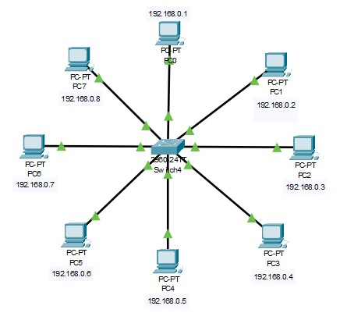

**Output:**

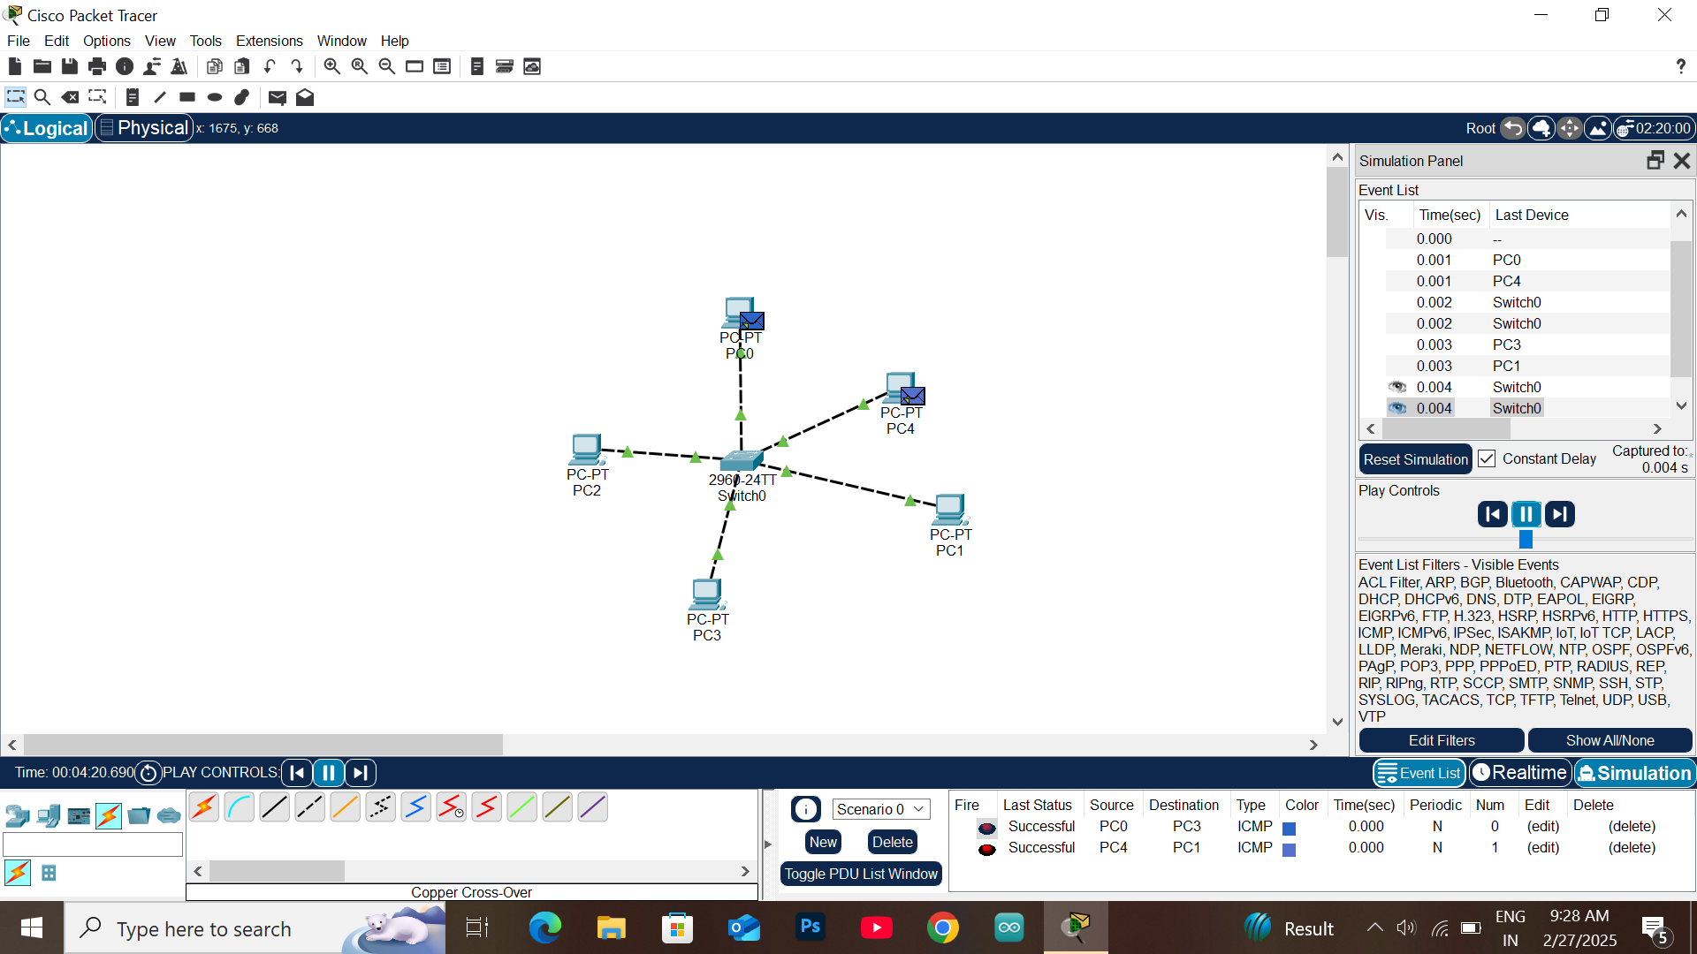

**Result:** Thus the Star topology is implemented with Packet Tracer simulation Tool.

**Date:**

# EXPERIMENT-3

**IMPLEMENTATION OF BUS TOPOLOGY USING PACKET TRACER**

**Aim:** To Implement a Bus topology using packet tracer and hence to transmit data between the devices connected using Bus topology.

**Software / Apparatus required:** Packet Tracer / End devices, Hubs, connectors.

**Steps for building topology:**

**Step 1: Start Packet Tracer**

**Step 2: Choosing Devices and Connections Step 3: Building the Topology – Adding Hosts**  Single click on the **End Devices**.

Single click on the **Generic** host.

Move the cursor into topology area.

Single click in the topology area and it copies the device.

**Step 4: Building the Topology – Connecting the Hosts to Switches**

Select a switch, by clicking once on **Switches** and once on a **2950-24** switch.

Add the switch by moving the plus sign “**+**”

**Step 5: Connect PCs to switch by first choosing connections**

Click once on the **Copper Straight-through** cable

Click once on **PC2**

Choose **Fast Ethernet**

Drag the cursor to **Switch0**

Click once on **Switch0**

Notice the green link lights on **PC** Ethernet NIC and amber light **Switch port**. The switch port is temporarily not forwarding frames, while it goes through the stages for the Spanning Tree Protocol (STP) process. After about 30 seconds the amber light will change to green indicating that the port has entered the forwarding stage.

Frames can now forward out the switch port.

**Step 6: Configuring IP Addresses and Subnet Masks on the Hosts**

To start communication between the hosts IP Addresses and Subnet Masks had to be configured on the devices. Click once on PC0. Choose the Config tab and click on FastEthernet0. Type the IP address in its field. Click on the subnet mask it will be generated automatically.

**Step 7: To confirm Data transfer between the devices**

Click on the node. Select desktop option and then command prompt. Once the window pops up, ping the IP address of the device to which node0 is connected. Ping statistics will be displayed.

**Diagram:**

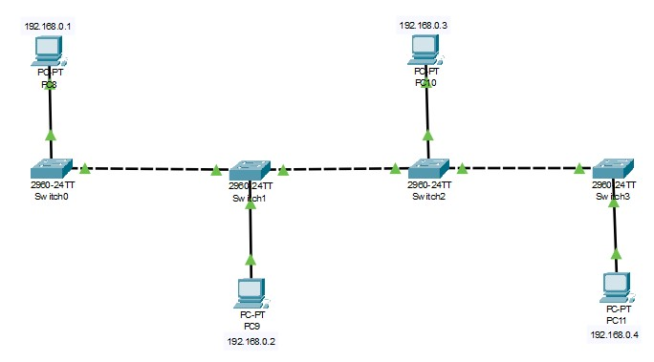

**Output:**

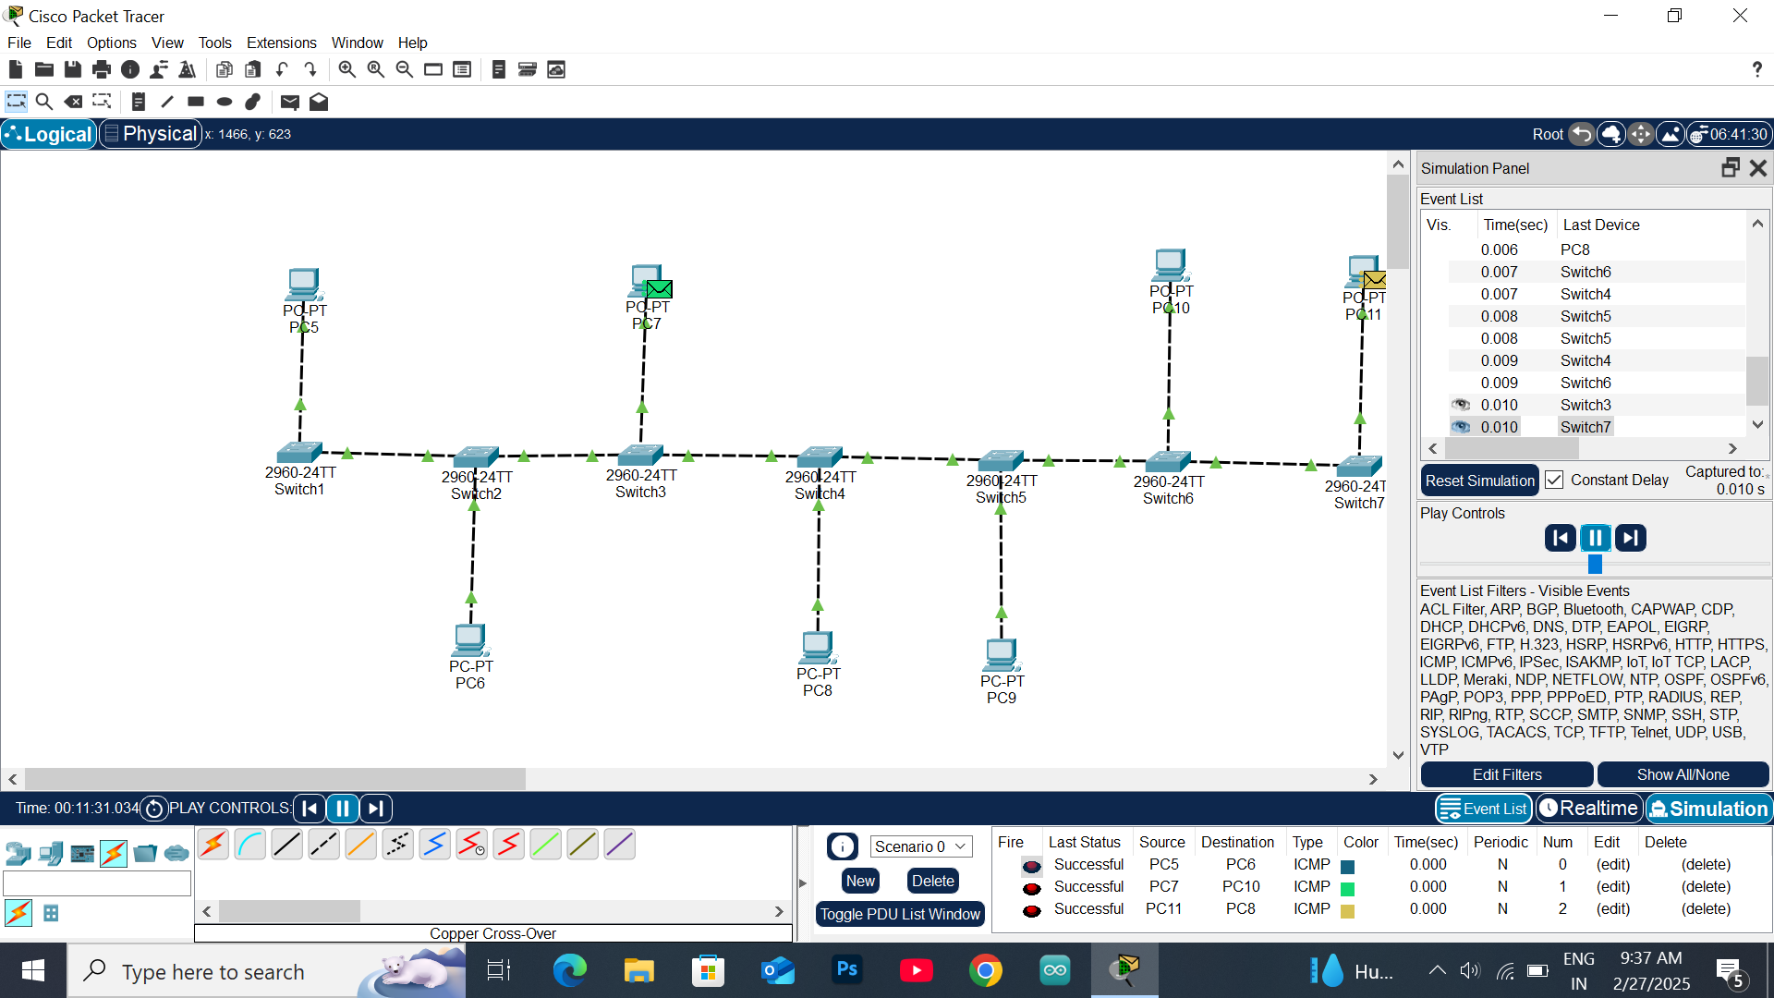

**Result:** Thus the Bus topology is implemented with Packet Tracer simulation Tool.

**Date:**

# EXPERIMENT-4

**IMPLEMENTATION OF RING TOPOLOGY USING PACKET TRACER**

**Aim:** To Implement a Ring topology using packet tracer and hence to transmit data between the devices connected using Ring topology.

**Software / Apparatus required:** Packet Tracer / End devices, Hubs, Connectors.

**Steps for building topology:**

**Step 1: Start Packet Tracer**

**Step 2: Choosing Devices and Connections Step 3: Building the Topology – Adding Hosts**  Single click on the **End Devices**.

Single click on the **Generic** host.

Move the cursor into topology area.

Single click in the topology area and it copies the device.

**Step 4: Building the Topology – Connecting the Hosts to Switches**

Select a switch, by clicking once on **Switches** and once on a **2950-24** switch.

Add the switch by moving the plus sign “**+**”

**Step 5: Connect PCs to switch by first choosing connections**

Click once on the **Copper Straight-through** cable

Click once on **PC2**

Choose **Fast Ethernet**

Drag the cursor to **Switch0**

Click once on **Switch0**

Notice the green link lights on **PC** Ethernet NIC and amber light **Switch port**. The switch port is temporarily not forwarding frames, while it goes through the stages for the Spanning Tree Protocol (STP) process. After about 30 seconds the amber light will change to green indicating that the port has entered the forwarding stage.

Frames can now forward out the switch port.

**Step 6: Configuring IP Addresses and Subnet Masks on the Hosts**

To start communication between the hosts IP Addresses and Subnet Masks had to be configured on the devices. Click once on PC0. Choose the Config tab and click on FastEthernet0. Type the IP address in its field. Click on the subnet mask it will be generated automatically.

**Step 7: To confirm Data transfer between the devices**

Click on the node. Select desktop option and then command prompt. Once the window pops up, ping the IP address of the device to which node0 is connected.

Ping statistics will be displayed.

**Diagram:**

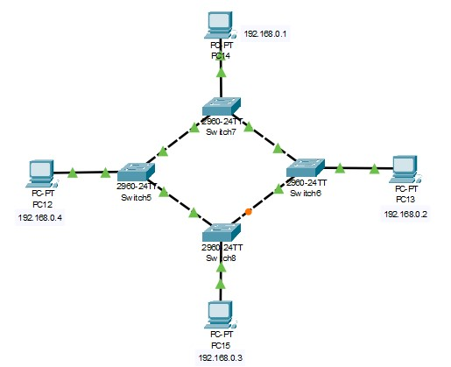

**Output**

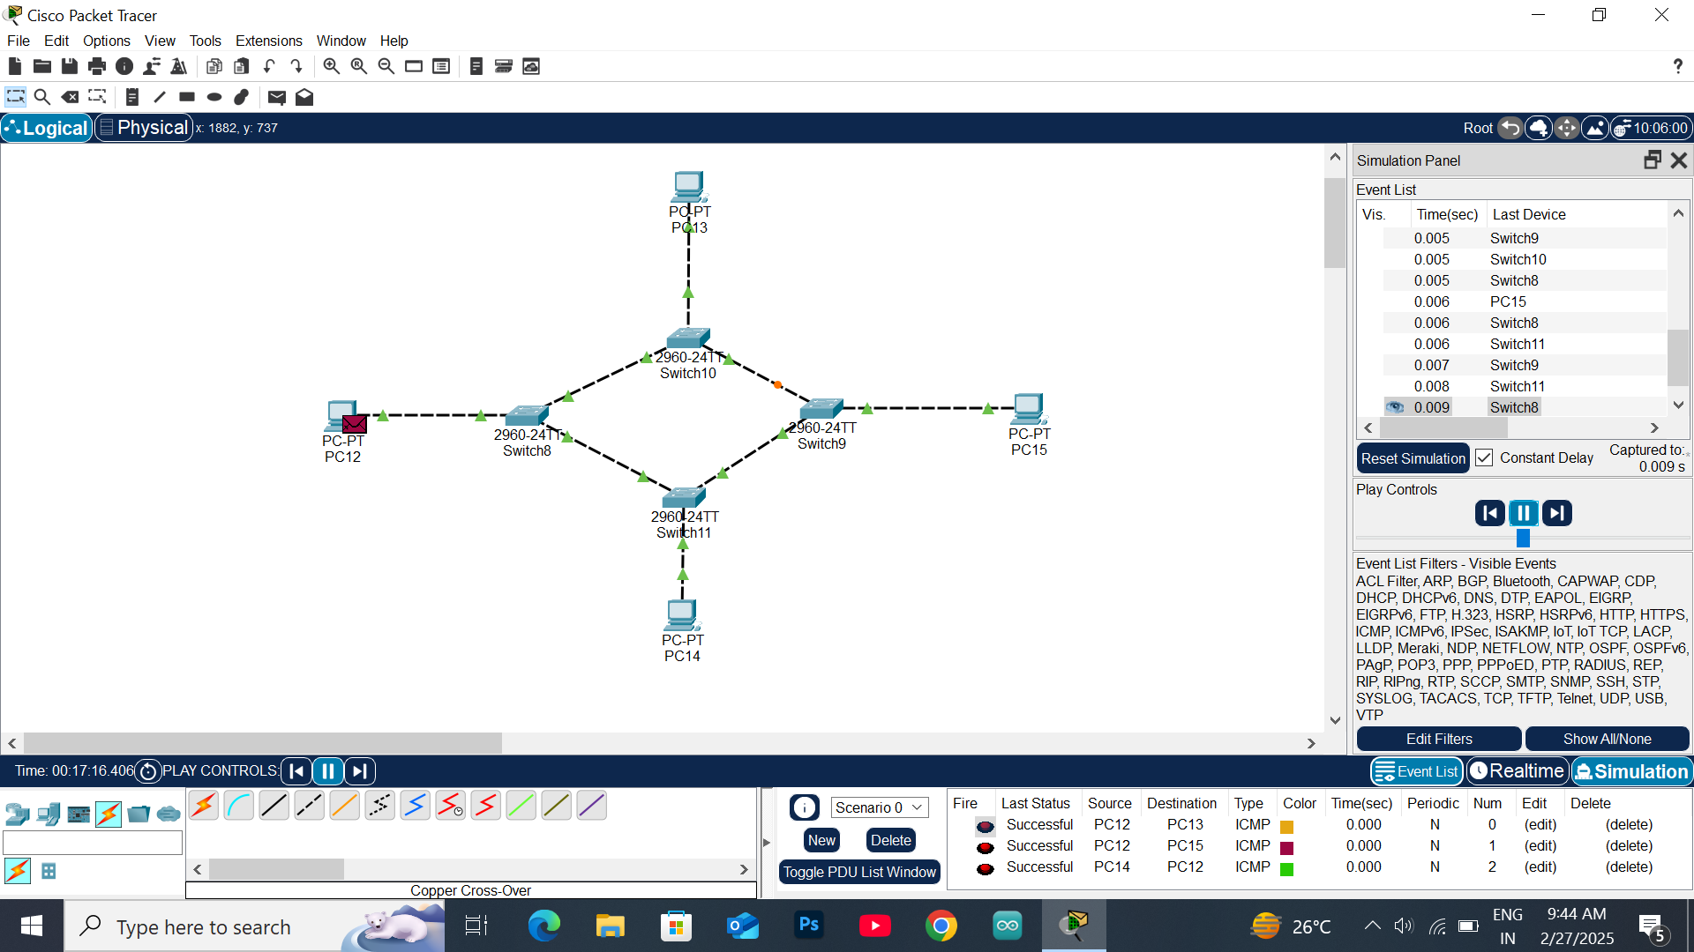

**Result:** Thus the Ring topology is implemented with Packet Tracer simulation Tool.

**EXPERIMENT-5**

**IMPLEMENTATION OF MESH TOPOLOGY USING PACKET TRACER**

**Aim:** To Implement a Mesh topology using packet tracer and hence to transmit data between the devices connected using Mesh topology.

**Software / Apparatus required:** Packet Tracer / End devices, Hubs, Connectors.

**Steps for building topology:**

**Step 1: Start Packet Tracer**

**Step 2: Choosing Devices and Connections Step 3: Building the Topology – Adding Hosts**  Single click on the **End Devices**.

Single click on the **Generic** host.

Move the cursor into topology area.

Single click in the topology area and it copies the device.

**Step 4: Building the Topology – Connecting the Hosts to Switches**

Select a switch, by clicking once on **Switches** and once on a **2950-24** switch.

Add the switch by moving the plus sign “**+**”

**Step 5: Connect PCs to switch by first choosing connections**

Click once on the **Copper Straight-through** cable

Click once on **PC2**

Choose **Fast Ethernet**

Drag the cursor to **Switch0**

Click once on **Switch0**

Notice the green link lights on **PC** Ethernet NIC and amber light **Switch port**. The switch port is temporarily not forwarding frames, while it goes through the stages for the Spanning Tree Protocol (STP) process. After about 30 seconds the amber light will change to green indicating that the port has entered the forwarding stage.

Frames can now forward out the switch port.

**Step 6: Configuring IP Addresses and Subnet Masks on the Hosts**

To start communication between the hosts IP Addresses and Subnet Masks had to be configured on the devices. Click once on PC0. Choose the Config tab and click on FastEthernet0. Type the IP address in its field. Click on the subnet mask it will be generated automatically.

**Step 7: To confirm Data transfer between the devices**

Click on the node. Select desktop option and then command prompt. Once the window pops up, ping the IP address of the device to which node0 is connected.

Ping statistic will be displayed.

**Diagram:**

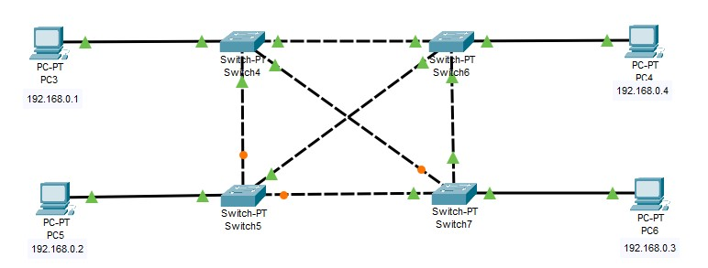

**Output:**

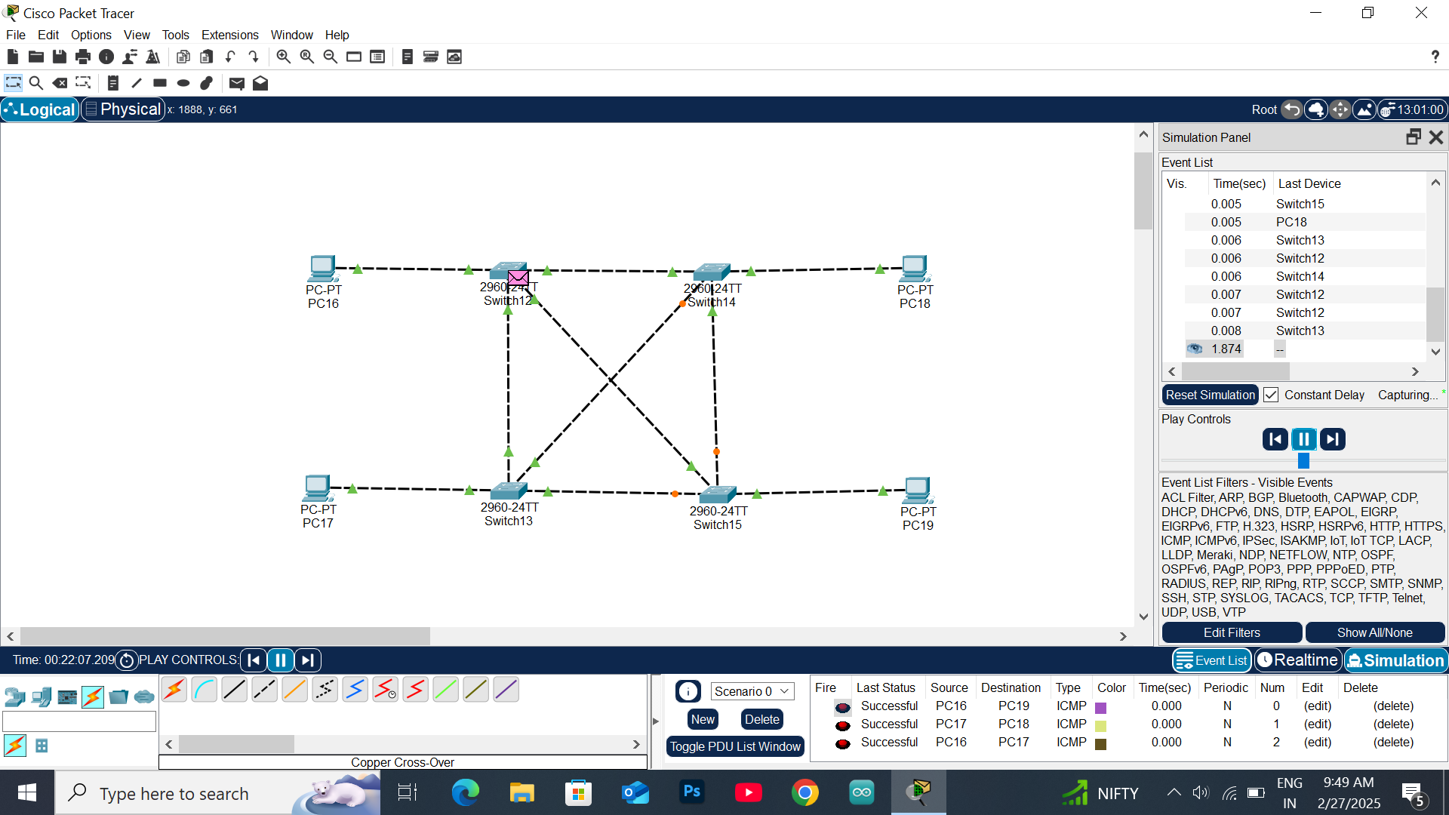**Result:** Thus the Mesh topology is implemented with Packet Tracer simulation Tool.

# EXPERIMENT-6

**IMPLEMENTATION OF TREE TOPOLOGY USING PACKET TRACER**

**Aim:** To Implement a tree topology using packet tracer and hence to transmit data between the devices connected using tree topology.

**Software / Apparatus required:** Packet Tracer / End devices, Hubs, connectors.

**Procedure:**

**Steps for building topology:**

**Step 1: Start Packet Tracer**

**Step 2: Choosing Devices and Connections Step 3: Building the Topology – Adding Hosts**  Single click on the **End Devices**.

Single click on the **Generic** host.

Move the cursor into topology area.

Single click in the topology area and it copies the device.

**Step 4: Building the Star Topology – Connecting the Hosts to Hubs**

Select a Hub, by clicking once on **Hub** and once on a **generic Hub**

Add the Hub by moving the plus sign “**+**”

**Step 5: Connect PCs to Hub by first choosing Connections**

Click once on the **Automatic cable selector**

Click once on **PC2**

Choose **Fast Ethernet**

Drag the cursor to **Hub0**

Click once on **Hub0**

**Proceeding in this way create three star topologies**

**Step 6: Building the Tree Topology – Connecting the Hubs to Active Hub**

Connect the hubs of star topologies to active hub to create tree topology.

**Step 7: Configuring IP Addresses and Subnet Masks on the Hosts**

To start communication between the hosts IP Addresses and Subnet Masks had to be configured on the devices. Click once on PC0. Choose the Config tab and click on Fast Ethernet0. Type the IP address in its field. Click on the subnet mask. It will be generated automatically.

**Step 8: Verifying Connectivity in Real time Mode** Be sure you are in **Real time** mode.

Select the **Add Simple PDU** tool used to ping devices.

Click once on PC0, then once on PC3.

The PDU **Last Status** should show as **Successful**.

Step 9: **Verifying Connectivity in Simulation Mode** Be sure you are in **Simulation** mode.

Deselect all filters (All/None) and select only **ICMP**. Select the **Add Simple PDU** tool used to ping devices Click once on PC0, then once on PC3.

Continue clicking **Capture/Forward** button until the ICMP ping is completed.

You should see the ICMP messages move between the hosts, hub and switch. The PDU **last status** should show as **Successful**.

**Diagram:**

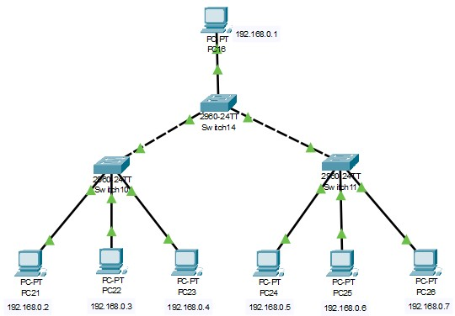

**Output:**

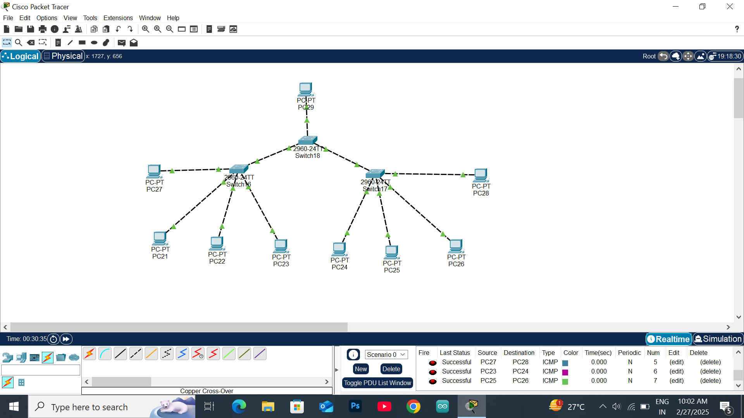

**Result:** Thus the Tree topology is implemented with Packet Tracer simulation Tool.

# EXPERIMENT-7 IMPLEMENTATION OF HYBRID TOPOLOGY (BUS AND RING TOPOLOGY) USING PACKET TRACER

**Aim:** To Implement a hybrid topology using packet tracer and hence to transmit data between the devices connected using tree topology.

**Software / Apparatus required:** Packet Tracer / End devices, Hubs, connectors.

**Steps for building topology:**

**Step 1: Start Packet Tracer**

**Step 2: Choosing Devices and Connections**

**Step 3: Building the Topology – Adding Hosts**  Single click on the **End Devices**.

Single click on the **Generic** host.

Move the cursor into topology area.

Single click in the topology area and it copies the device.

**Step 4: Building the Bus Topology – Connecting the Hosts to Hubs**

Select a Hub, by clicking once on **Hub** and once on a **generic Hub**

Add the Hub by moving the plus sign “**+**”

**Step 5: Building the Ring Topology – Connecting the Hosts to Hubs**

Select a Hub, by clicking once on **Hub** and once on a **generic Hub**

Add the Hub by moving the plus sign “**+**”

**Step 5: Connect PCs to Hub by first choosing Connections**

Click once on the **Automatic cable selector**

Click once on **PC2**

Choose **Fast Ethernet**

Drag the cursor to **Hub0**

Click once on **Hub0**

**Proceeding in this way create three Bus topologies**

**Step 6: Building the Tree Topology – Connecting the Hubs to Active Hub**

Connect the hubs of star topologies to active hub to create tree topology.

**Step 7: Configuring IP Addresses and Subnet Masks on the Hosts**

To start communication between the hosts IP Addresses and Subnet Masks had to be configured on the devices. Click once on PC0. Choose the Config tab and click on FastEthernet0. Type the IP address in its field. Click on the subnet mask. It will be Generated automatically.

**Step 8: Verifying Connectivity in Realtime Mode**  Be sure you are in **Realtime** mode.

Select the **Add Simple PDU** tool used to ping devices.

Click once on PC0, then once on PC3.

The PDU **Last Status** should show as **Successful**.

Step 9: **Verifying Connectivity in Simulation Mode** Be sure you are in **Simulation** mode.

Deselect all filters (All/None) and select only **ICMP**. Select the **Add Simple PDU** tool used to ping devices Click once on PC0, then once on PC3.

Continue clicking **Capture/Forward** button until the ICMP ping is completed. The ICMP messages move between the hosts, hub and switch. The PDU **Last Status** should show as **Successful**.

**Diagram:**

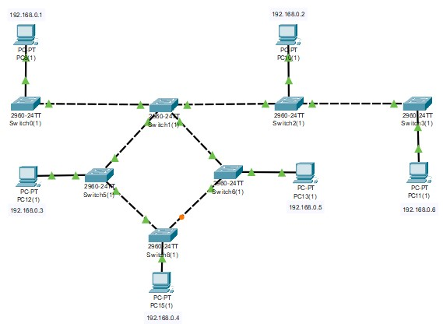

**Output:**

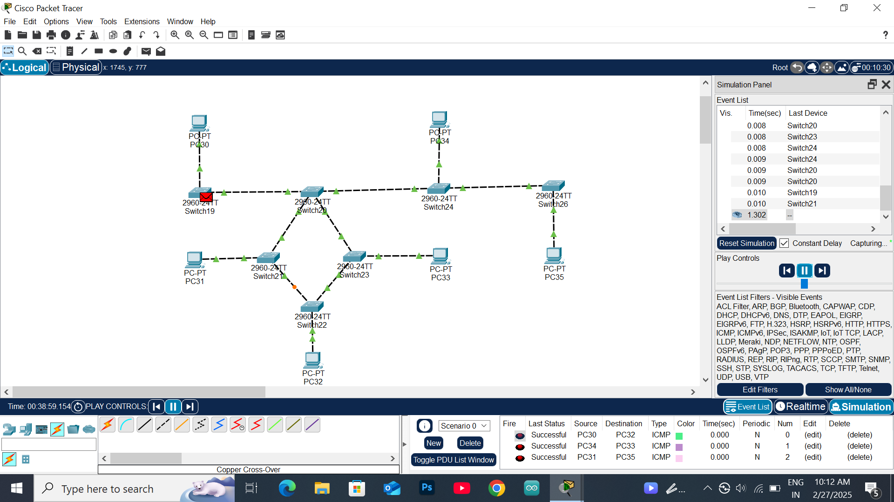

**Result:** Thus the Hybrid topology is implemented with Packet Tracer simulation Tool.

**Date:**

**EXPERIMENT-8**

**DATA LINK LAYER TRAFFIC SIMULATION USING PACKET TRACER ANALYSIS OF ARP**

**Aim**: To implement Data Link Layer Traffic Simulation using Packet Tracer Analysis of ARP.

**Software / Apparatus required:** Packet Tracer / End devices, Switches, connectors. **Requirements:**

1. End device - They are the devices through which we can pass message from one device to another and they are interconnected.

2 Switch/Hub - Interface Between two devices.

3. Cable - Used to connect two devices **Procedure:**

1. Open packet tracer.
2. Click on the list the available capture interface.
3. Choose the PCS, server and Hub.
4. Later give connection from hub to the remaining pcs.
5. Give IP address to the pcs with configuration.
6. Simulate the source and destination.

**Diagram**

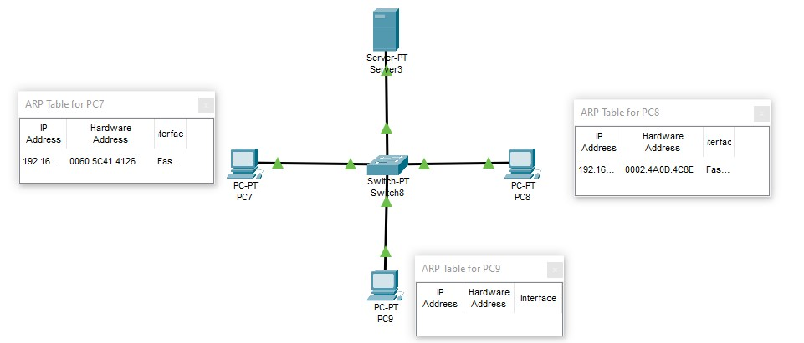

**Output:**

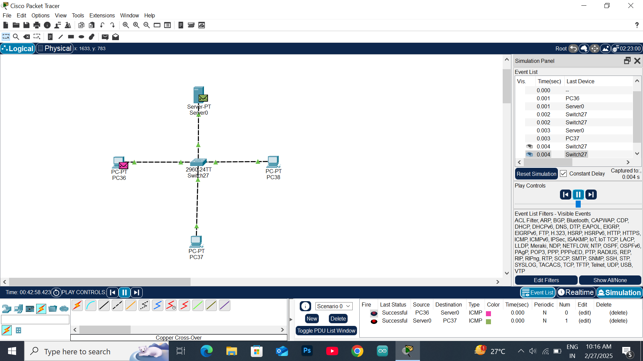

**Result:** Thus theData Link Layer Traffic Simulation using Packet Tracer Analysis of ARP is implemented.

**EXPERIMENT-9**

**DATA LINK LAYER TRAFFIC SIMULATION USING PACKET TRACER**

**ANALYSIS OF CSMA/CD & CSMA/CA**

**Aim**: To implement Data Link Layer Traffic Simulation using Packet Tracer Analysis of CSMA/CD & CSMA/CA.

**Software / Apparatus required:** Packet Tracer / End devices, Switches, connectors. **Requirements:**

1. End device - They are the devices through which we can pass message from one device to another and they are interconnected.

2 Switch/Hub - Interface Between two devices.

3. Cable - Used to connect two devices **Procedure:**

STEP 1: Click on end devices, select generic Pc’s drag and drop it on the window. Click on SWITCH drag and drop it on the window.

STEP 2: Select the straight through cable and connect all end device to switch. Assign the IP address for all end devices. (Double click the end device Select → desktop → IP configuration static)

STEP 3: Now set the IP address to Host A (192.168.1.1) in static mode. Similarly set IP address for Host B (192.168.1.2) and Host C (192.168.1.3)

STEP 4: To view the IP address, give ip config command in command prompt. Using ping command, we can establish communication between two host devices.

STEP 5: Now display the packet transmission in simulation mode.

Diagram:

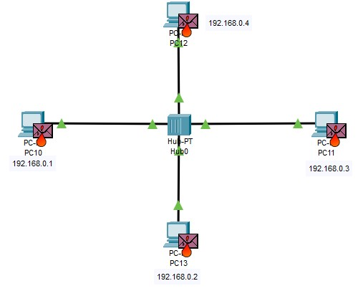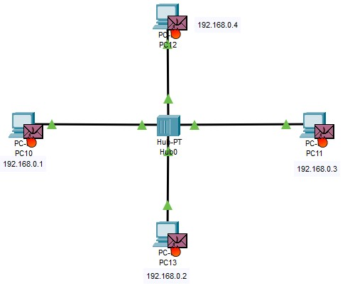

Output:

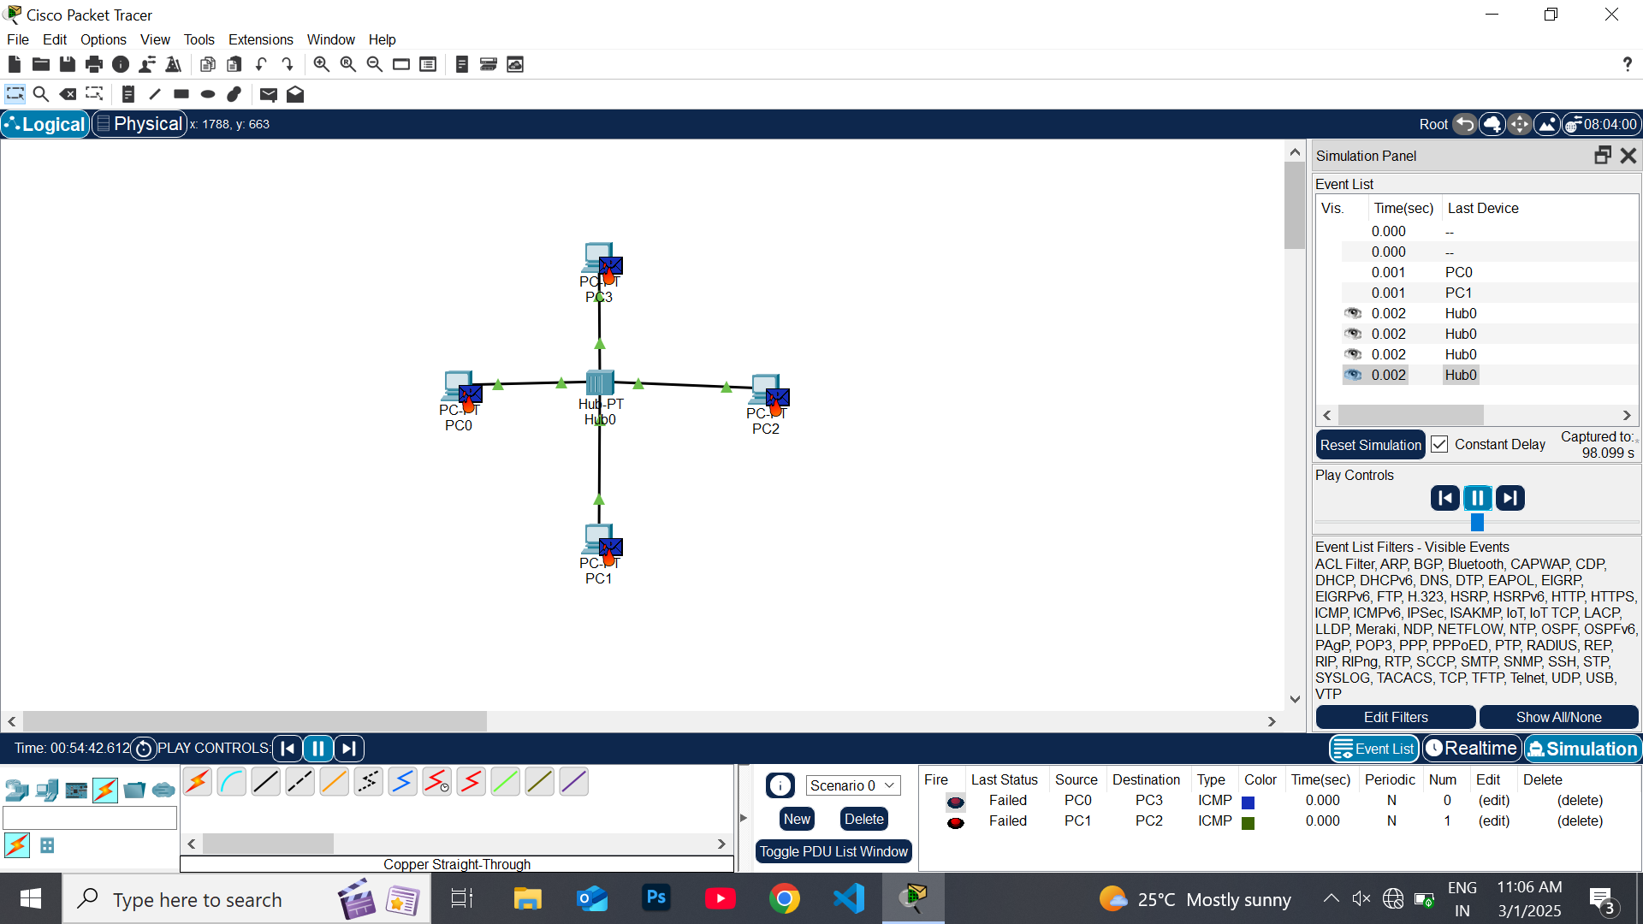

**Result:** Thus Data Link Layer Traffic Simulation using Packet Tracer Analysis of CSMA/CD & CSMA/CA is implemented successfully.

**EXPERIMENT-10**

**MAKING COMPUTER LAB IN CISCO PACKET TRACER**

**Aim:** Making Computer Lab in Cisco Packet Tracer.

**Software / Apparatus required:** Packet Tracer / End devices, Switches, connectors.

**Procedure:**

Step 1: Launch Cisco Packet Tracer and create a new project.

Step 2: Select the appropriate network devices for your lab. In this case, you will need computers, switches, and routers. You can find these devices in the "End Devices," "Switches," and "Routers" sections of the device list.

Step 3: Drag and drop a switch onto the workspace area. Connect the switch to the power source by clicking on the "Connection" option and selecting "Power."

Step 4: Connect computers to the switch by dragging and dropping them onto the workspace area. Click on the "Connection" option and select "Fast Ethernet" to connect the computers to the switch.

Step 5: Repeat Step 4 to add more computers to the lab. You can adjust the number of computers as per your requirements.

Step 6: Connect the switch to a router. Drag and drop a router onto the workspace area and connect it to the switch using a serial cable. To do this, click on the "Connection" option, select "Serial," and then select the appropriate serial interface on the router.

Step 7: Configure IP addresses on the computers. Select a computer, click on the "Desktop" tab in the device configuration panel, and configure the IP address, subnet mask, and default gateway for each computer.

Step 8: Configure IP addresses on the router interfaces. Select the router, click on the "CLI" tab in the device configuration panel, and enter the interface configuration mode. Assign IP addresses to the router interfaces connected to the switch and computers.

Step 9: Test connectivity. Open the command prompt on each computer and try to ping other computers and the router's interfaces to ensure connectivity.

Step 10: Customize and expand the lab as desired. You can add additional devices, configure VLANs, implement security measures, or set up servers within the lab environment.

Diagram:

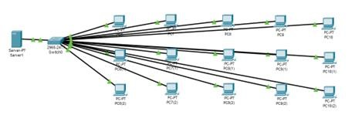

**Output:**

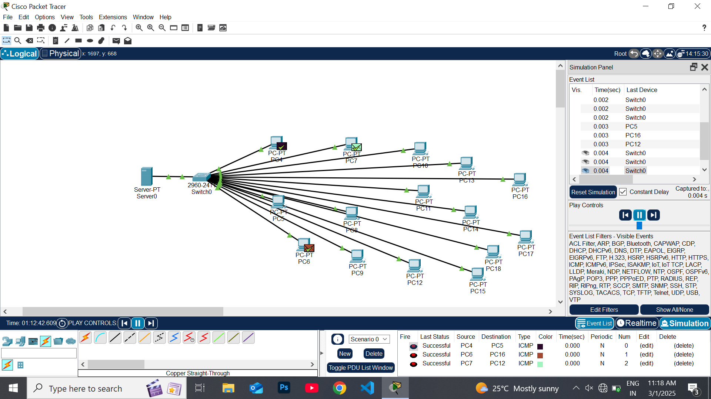

**Result**: Thus the Computer Lab in Cisco Packet Tracer is set up successfully.